**Vision Document for “eShopper”**

**Team members:**

|  |  |
| --- | --- |
| Adeleke Oyebode Adeola | **610516** |
| Amit Bhattarai | **610514** |
| Ny Aina Michael Andriantsoa | **610574** |
| Lamhot Siagian | **610517** |

**1. Introduction**

eShopper is a web application platform that provides service to buy and sell products. In order to sell a product, the seller (merchant) can add, update and delete a product. Detailed information of the products are name, category, price, and description. As a buyer, users will register to the system with specific information such as username, password, e-mail, and address. After they register, they need to login to identify their order.

To make the system more intuitive, the web application should provide search and filters products that help users to easily find products, then add to cart. When users already have a list of products in their cart, sometimes they leave it, then next time, login to continue their transaction. In this case, users need a menu to display a list of their orders. Additional functionalities are search products and filters that help users to easily find products.

In terms of merchant, they need to know, if there is any order from buyers, then they will get notification or will be able to see the list of product requests. After viewing the list of requested products, they can reject or approve the order of the specific buyer.

**2. Positioning**

**2.1 Problem Statement**

|  |  |
| --- | --- |
| **The problem of** | As merchant, someone has actual product and location for selling their products  However as buyer:  - Buyer has no much time to reach seller location, he/she only want to order through the web and products will be deliver to his/her addresses  - Buyer have difficulties to find right products (best price and good quality) if using offline market |
| **Affects** | Merchant, Buyer |
| **the impact of which is** | * Offline seller will not have much income, since buyer tends to buy online * Buyer will waste their time going to reach seller location * Chance to get good product will be reduced, since buyer has limitation to compare the price, and also there is no review of that products |
| **a successful solution would be** | * eShopper will enable merchant to add all his/her products * Buyer can easily find the right products through search, filter feature, and product review data. |

**2.2 Product Position Statement**

|  |  |
| --- | --- |
| For | Buyer: want to purchase products from online shopping web application  Merchant (Seller) : want to sell his/her products through online shopping web application |
| Who | Buyer and Merchant (Seller) |
| The (product name) | Online Shopping (eShopper) |
| That | * Merchant: Easy to register, to upload products, to process buyer order, along with a trusted system. * Buyer: easy to access along with fast response |
| Unlike | Amazon, eBay |
| Our product | * More flexible * More easy to register as buyer or merchant (*userfriendly)* * Intuitive user interface |

**3. Stakeholder Descriptions**

Stakeholders are the various interest groups who have a role or more to play in the development and usage of the application.

**3.1 Stakeholder Summary**

In this application, the following are stakeholders:

* Merchants(Sellers) who sell products
* Buyers who buys the products
* Site Administrator who maintains and manages the eShopper portal
* Investors who are sponsoring the project
* Shareholders

**3.2 User Environment**

eShopper is an online-based web portal opened to all prospective merchants and buyers. The portal shall be managed by the Administration team who shall oversee the day-to-day working/interactions within the portal users.

Being a web portal, it shall be hosted on a secure web server to start with. Subsequently, mobile apps may be developed to reach the prospective mobile users. As for this project, we are limiting development to web portal.

A team of software developers will work on developing basic functionalities such as User Authentication, Merchants Creation of products and buyers can purchase products on the site.

In this portal, the following key roles are involved:

**Merchants**:

* Can create their user accounts and are verified by the admin
* After verification, merchants can post products for sales. This product shall include its price, pictures, brief descriptions and name of product
* Can view orders of their products

**Buyers**:

* Can browse to see different products
* Can user accounts
* Order for goods

**Admin:**

* View all merchants
* View all buyers
* View all transactions

There are no external requirements for this application.

**4. Product Overview**

E-Shopper is an ongoing project consisting of online shopping and vending quite similar to Amazon, Alibaba or any other online shopping plateforme which are the goal of this web application. At the end of the construction, we are expecting a fully working and standalone web application accessible on the internet with the ability to persist data to our database with all the security features especially the user authentication.

**4.1 Product Perspective**

Our expectation is to have component based application which will become the root of any future extension plan, which means any upgrades of this application will not change the basic features nor the implementation of all the use case of the project, but instead extend from the existing source and create new components for new features or optimisation.

This application will mostly contains the following main components:

* User
* Account
* Product
* Order
* Transaction
* Payment
* Shipping
* Notification

The following points are about the main features:

* Security
* Data persisting

We are also planning a Mobile application for E-Shopper for future versions of the project.

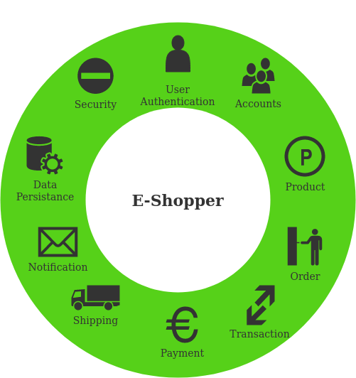

**4.2 Assumptions and Dependencies**

For the development of this project, our database will be MySQL and it is subject to changes as time goes and as the number of users increases. We may change from relational database to non-relational database according to future needs and of course, it will not change the implementation of the features of the project since we are working in a component based structure.

Also, the implementation of the mobile application may also result in the extension of some services in the back end server, such as adding new components for REST services, extending the scope of the security to cover the navigation through the mobile application.

**4.3 Needs and Features**

**The following features will be a part of the application:**

1. **Authenticate and authorize customers/users, merchant and admins**

This will allow users to use only the functions that they are authorized to use and make sure our application is secure

1. **Allow customers to browse through products using catalogs**

This feature will allow customers to interactively browse through products that they are interested in

1. **Allow customers to add products to cart, remove them or modify the number of products to be ordered**

These set of features will allow users to add items to cart or modify them

1. **Allow customers to edit their details**

Customers can edit their details such as name, address, phone numbers and so on

1. **Allow customers to add addresses and payment details and place an order**

Customers can add new addresses and payment details if they want

1. **Allow merchants to add new products through their dashboards**

Merchants will be able to add new products to their pages

1. **Allow merchants to remove products, change details or change their availability**

Merchants can remove any existing product or change the number of products available

1. **Allow merchants to view currently placed orders**

Merchants will be able to view current orders placed for their items

1. **Allow admins to manage users, their details and change their roles**

Admins can manage users, add or remove new user or change their roles

**4.4 Alternatives and Competition**

Among various alternatives and competition, these are the few significant ones:

1. Amazon

Strength: Simple and easy to use UI, tons of merchants and customers, excellent payment service

Weakness: Can be expensive, less control for a merchant

1. Ebay

Strength: Merchant has lots of control, tons of products to browse from, cheap to expensive

Weakness: Uses third party payment system that can be insecure at times, products can be different from advertised

**5. Other Product Requirements**

* Registration process should be simple and easy to use
* Search entry should be visible in toolbar
* Search products performance should be fast